**CLASSICAL REPORTS:**

**INPUT:**

**OUTPUT:**

**INTERACTIVE REPORTS:**

**INPUT:**

**OUTPUT:**

**SUBROUTINES:**

**CALL BY VALUE:**

**CALL BY REFERENCE:**

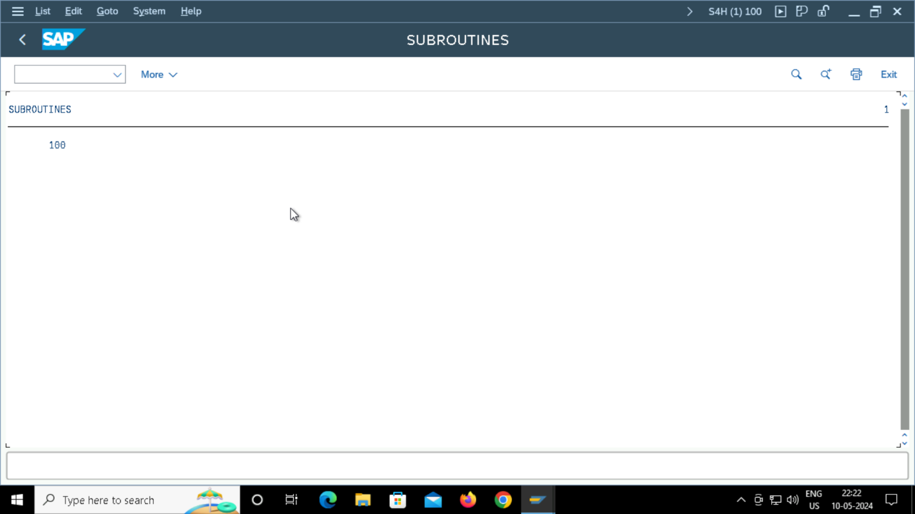

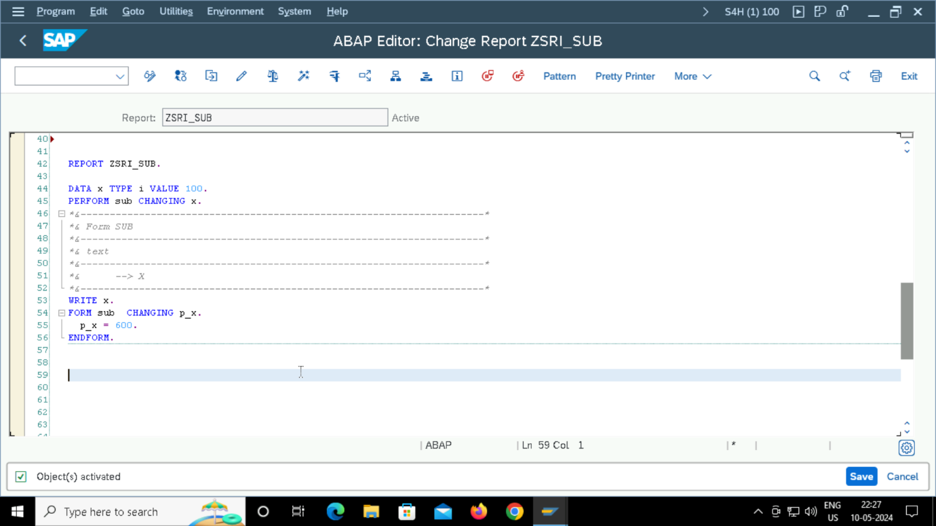

**CALL BY VALUE AND RETURN:**

**INTERNAL TABLE PROGRAMS:**

**INSERT:**

**INSERT LINE:**

**MODIFYING THE INDEX:**

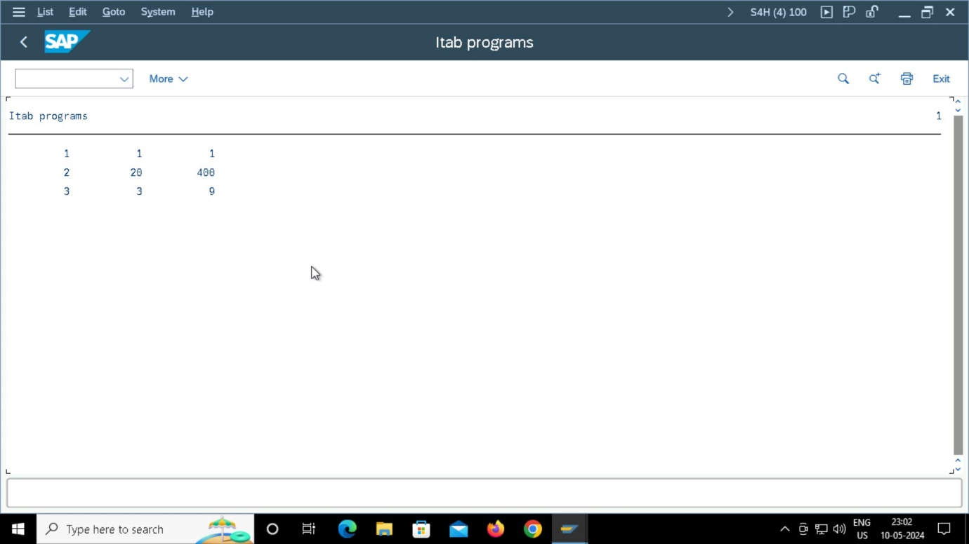

**COLLECT :**

**FIELD SYMBOLS:**

**FUNCTION MODULES:**

